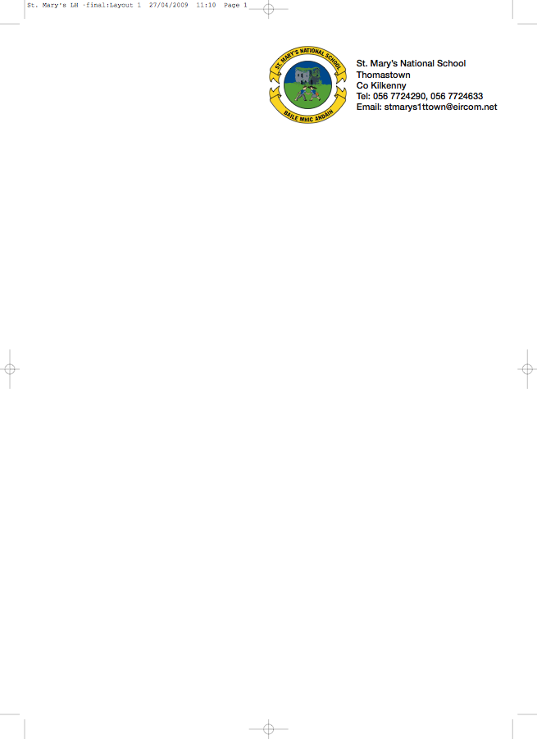

SENIOR INFANTS BOOKLIST 2018/’19

Ms. Kelly

GAEILGE Bua na Cainte B - Edco

ENGLISH New Wave Handwriting Senior Infants (Prim Ed)
What a Mess! Folens)
Stop That Dog (Folens)
The above 3 English Books are available secondhand from present Senior Infants

MATHS Cracking Maths - Senior Infants (gill & Macmillan)

S.E.S.E. Windows on the World Activity Book B (Edco)

2 Topped Pencils
Rubber/Topper
Box of crayons/twistables
1x120 page copy
A4 Mesh Zipped Bag

Please put the child’s name on outside cover of all books.

To cover the cost of :Photocopying, Copies, Jolly Phonics Workbook etc.,
Art & Personal Accident Insurance (24 hr Cover).
Please put €40 in an envelope and give it to the teacher in September.

No ‘wheelie’ bags.

All school stationary available at Liam Reddy’s shop

