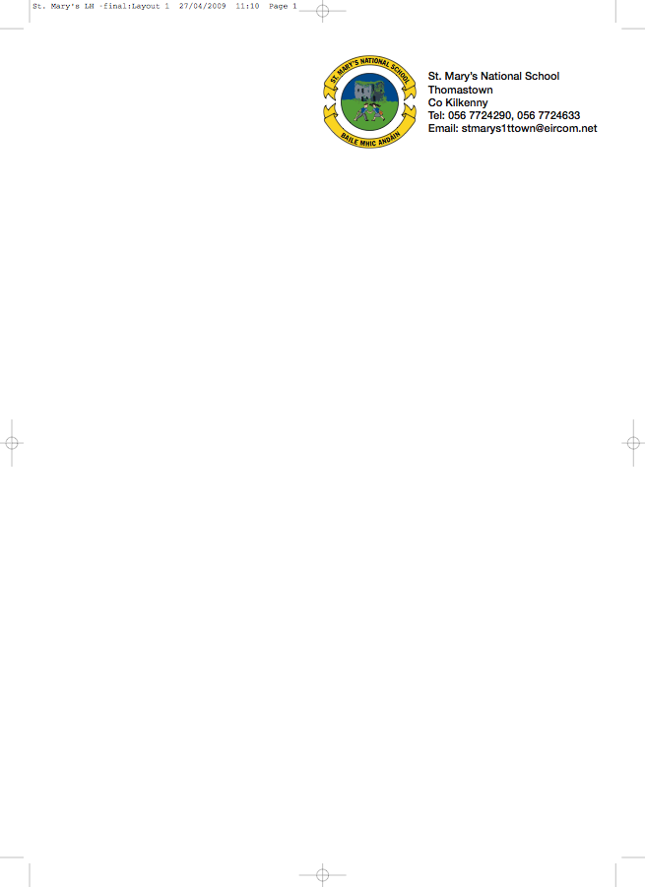

BOOKLIST 2018/’19

JUNIOR INFANTS 2 - MS. A. STAPLETON - ROOM 3

GAEILGE Céim ar Chéim A (C.J. Fallon)

ENGLISH Reading Zone Pre-Reading Activity Book (Folens)
Just Write A1 Introduction to joined script and cursive writing (Edco)

MATHS Busy at Maths – Junior Infants (CJ Fallon)

To cover the cost of:

- COPIES/PENCILS/FOLDERS & CRAYONS (These items will be purchased & distributed by the teacher)
- ART/CRAFT/PHOTOCOPY
- PERSONAL ACCIDENT INSURANCE (24 hour cover - includes activities outside school hours)

Please put €50 in an envelope with the child’s name marked clearly on the front.

Parents please
- write your child’s name on all books/workbooks

- Have your child’s name on coats, jumpers, lunch boxes etc.

- Please put all books in a bag and give it to the teacher.

NOTE: School bags should be big enough to fit an A4 folder, lunch and a drink.

No ‘wheelie’ bags.

All school stationary available at Liam Reddy’s shop

.

