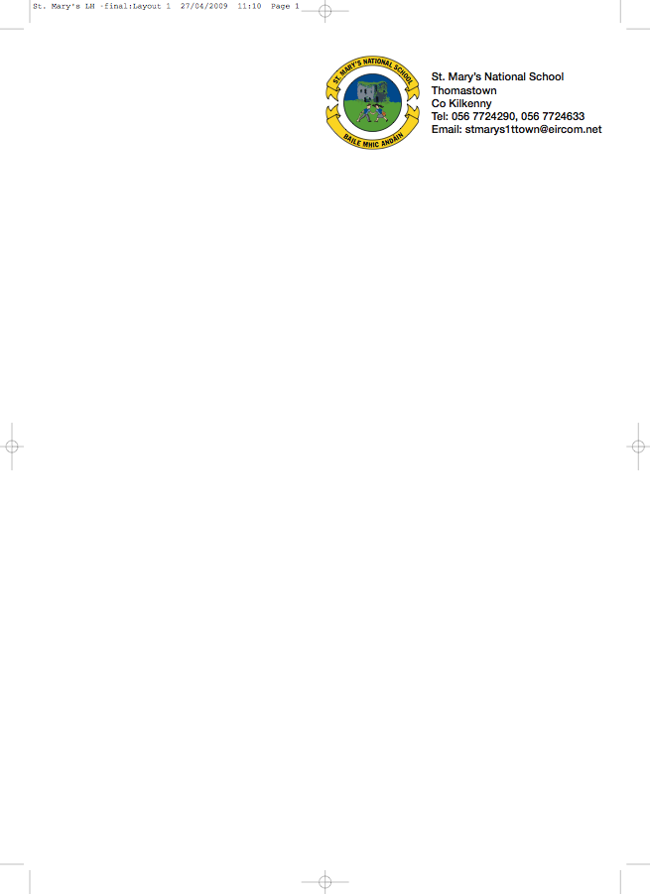

FIRST CLASS BOOKLIST 2018/’19

Ms. O’Shea

ENGLISH The Literacy Lift Off programme is being used in 1st class. All reading books and workbooks for the programme MUST be rented.
Please put €15 in an envelope marked ‘Book Rental’ with your child’s name and return to the class teacher in September.

The following must be purchased:

ENGLISH New Wave English in Practice 1st Class (Prim-Ed)

SPELLING Jolly Phonics Grammar 1 Pupil Book

GAEILGE Bua na Cainte 1

MATHS Busy at Maths 1 (Fallons)
Time for Tables (Edco.)
Master Your Maths 1 (Fallons)

SESE Small World 1st Class (Fallons)

COPIES 1 Notebook (48 pages)
1 x 88page copy
1 Homework Diary (Fallons)
Box of Crayons/Colouring Pencils, Pencils
Rubber, Topper.

PLEASE HAVE COVERS AND NAMES ON ALL BOOKS & COPIES

- Please put €30 in a named envelope to cover the cost of photocopying, art materials, copies and pupil insurance (24hr cover) and give it to the teacher in September.

No Wheelie Bags - All school stationary available at Liam Reddy’s shop

School Uniform Details
The school uniform for Junior and Senior Infants is a track suit comprising a blue sweat shirt with school crest, navy pants and white polo shirt.

The school uniform for all other classes (1st to 6th class) is a grey shirt, grey trousers for boys and grey skirt or pinafore of appropriate length, for girls (trousers optional for girls), school tie (not elasticated type) and blue jumper with school crest.

On P. E. days and other designated days the pupils will wear a white polo shirt, plain unbranded navy track suit ends (not leggings) and a plain unbranded navy sweatshirt. During hot weather the children can wear Plain Navy Shorts (knee Length)

