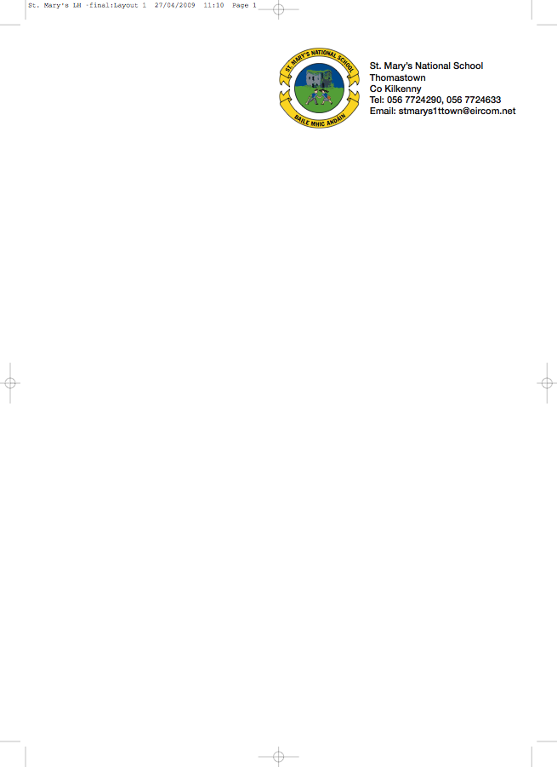

FIFTH CLASS BOOKLIST 2018/’19

Ms. Stapleton Rm13
Books Available to Rent

GAEILGE Béal Beo 5
Graméir le Chéile

ENGLISH Reading Zone: Call of the Sea
Reasons to Write 5
Word Wizard 5
Word Wise 5
Novels: A variety of novels will be used during the year
MATHS 5th Class: Planet Maths 5th

S.E.S.E. *History, Geography & Science
We use different books and schemes throughout the year

RELIGION Grow in Love 5th/6th Class

Workbooks: To be purchased new

Irish
Rírá 5 (CJ Fallon)
Irish Dictionary (Collins)

English
Spellwell 5 (CJ Fallon)

English Dictionary: Oxford Dictionary Irish Edition Recommended

Mental Math
5th New Wave Mental Maths 5th Class (Prim-ed)
Table book
Copies
1 A4 Hardback (English) Homework Diary
1 A5 Hardback (Gaeilge)
5 120 page copies (3 English, 2 Gaeilge) Book Rental: €28
6 x 88 page copies (History, Science, Geography) Art & Craft: €30
Spare for h/w, RE/SPHE and Free) Insurance: €7
3 squared maths copies Please put in envelope with child’s name to be
2 folders with 60 plastic pockets each collected in September.

PLEASE HAVE COVERS AND NAMES ON ALL BOOKS & COPIES

No Wheelie Bags

All school stationary available at Liam Reddy’s Shop

Please see overleaf for Uniform Details

