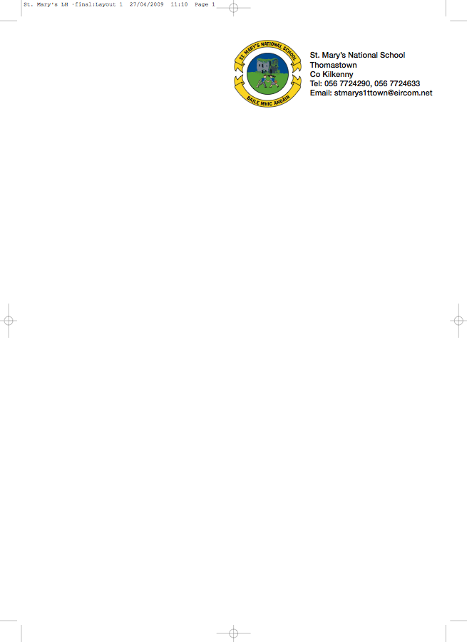

Fourth Class - BOOKLIST 2018/’19

Class Teachers: Ms. Hogan and Ms. Muldowney

GAEILGE Rírá (Fuaimeanna, Focloir agus frasai) (CJ Fallon)

ENGLISH New Wave English in Practise (Prim Ed)
English Dictionary
Just Write 4a (Edco)

MATHS New Wave Mental Maths 4th Class (Prim Ed) Number Facts 4 (A new approach to tables) (Edco)
Tables Book

- 8 x 120 page copies 4 x 88 page copies 3 x Squared Maths copies
(Please cover copies and write your name on the outside cover)
- Homework Diary
- 1 A4 Folders with Plastic Pockets
- 1 A4 Cardboard folder
- 1 A4 Hardback Notebook
- 1 A4 Scrapbook for projects
- Whiteboard Markers
- Pritt stick, scissors, colouring pencils/ crayons, a red a blue pen and 2 pencils
Book Rental
Béal Beo 4
Grow in Love 4
Wordwise4, Reasons to Write, Word Wizard 4
Busy at Maths 4
Novels/Guided Reading/ English Reader
History, Geography and Science

Should you wish to avail of the book rental scheme, please put €30 in an envelope and give to me in September.
Please put €40 in a separate envelope for Art, craft, photocopying and pupil insurance (24 hr cover)

No Wheelie Bags
All school stationary available from Liam Reddy’s Shop

