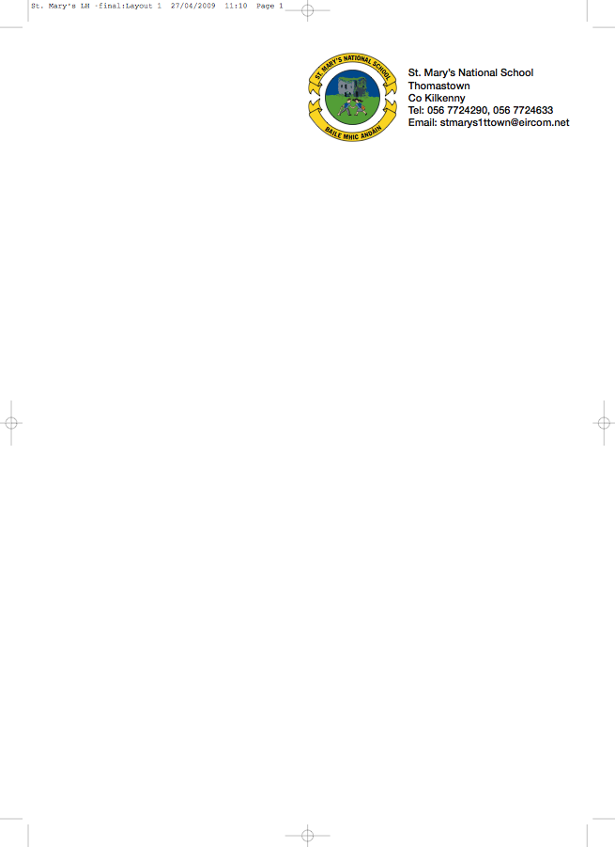

Third Class - BOOKLIST 2018/’19

Class Teacher: Ms. S. Stapleton

Irish Beál Beo (EDCO)
Litrigh É 3 (EDCO)

ENGLISH Selection of Readers/Novel to rent only
Exercise your English (rent only)
Reasons to Write 3 (EDCO)
Just Write 4a (EDCO)

MATHS Busy at Maths 3 (CJ Fallon) Master Your Maths 3 (CJ Fallon)

RELIGION Grow in Love Primary 5 (available to rent)

School Insurance, Photocopying, Art - €50. Please put this amount in an envelope with your child’s name on it and give it to the teacher in September.

Included in the €50 charge is the cost of pupil insurance, €7 for the cost of photocopying for SESE and Music (no books are required to be purchased). €7 for the rental of the selection of English readers/novels and €3 for the rental of Exercise Your English. This amount covers the purchase of 1x80page activity scrap book for SESE subjects.

Copies

Homework Journal – Fallons 2x 40 page Maths copies

9 x 40 page (A12) writing copies 2 x 88 page (A11) writing copies

All children must have

Table Book
English Dictionary (CJ Fallon New Children’s Dictionary, Irish Edition, recommended)
Folder with plastic pockets

2 x HB Pencils, 1 red Bic pen, 30cm fuler, pencil sharpener, Pritt Stick, Small box of colouring pencils. Please ensure all copies are covered and labelled.

No Wheelie Bags
All school stationary available from Liam Reddy’s Shop

See overleaf for uniform details.

