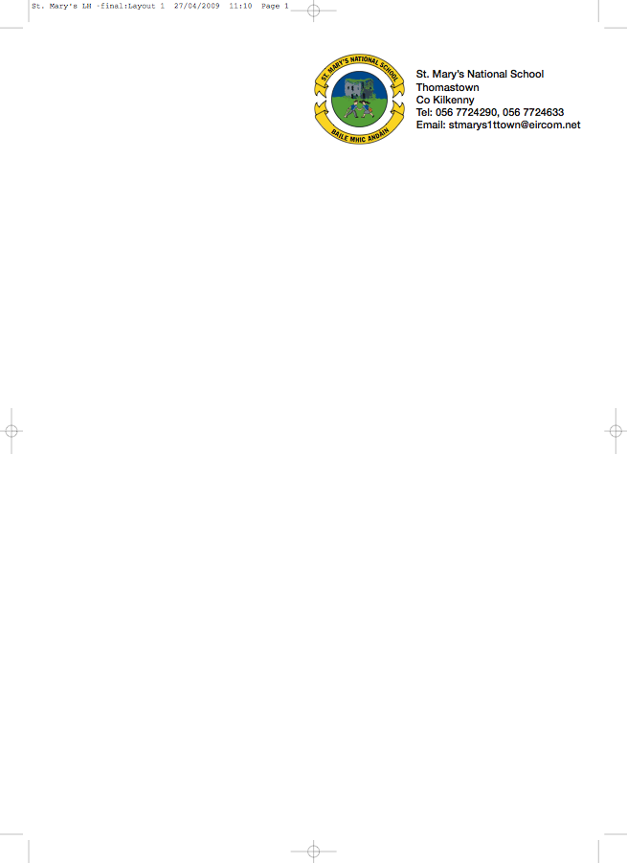

SECOND CLASS BOOKLIST 2018/’19
Mrs. Moore
ENGLISH New Wave English in practice (Prim-Ed Daily Workbook
Oxford Children’s Dictionary (Irish Edition)
Just Write 3a (Edco)

GAEILGE Céim ar Chéim Reader – “Chairde le Cheile” Leabhar 2
Céim ar Chéim Workbook Rang a Dó
(They come as a pack)

MATH Tables Book
Master Your Maths (Mental Maths) 2 (CJ Fallon)
Busy at Maths 2 (CJ Fallon) – Second Class

S.E.S.E. Window on the World Activity Book 2
MUSIC Recorder – available in school in September
COPIES/ 8 (88page) Writing Copies
SUPPLIES Homework Diary (C.J. Fallon)
Pencils, Rubber, Red Pen, Topper, Crayons, Ruler
2 Plastic Pocket Folders to fit A4 paper (with front fastner)

- Please have covers and names on all books and copies
- Please put €40 into an envelope to cover the cost of photocopying art materials, pupil insurance (24hr cover) (The money is to be given to the teacher in September in an envelope with the child’s name on it).
€15 is required for book rental to cover the cost of the new Literacy Programme, Spelling Book and other readers. Please put this amount in an envelope and give it to the teacher in September.

School Uniform Details
The school uniform for Junior and Senior Infants is a track suit comprising a blue sweat shirt with school crest, navy pants and white polo shirt.

The school uniform for all other classes (1st to 6th class) is a grey shirt, grey trousers for boys and grey skirt or pinafore of appropriate length, for girls (trousers optional for girls), school tie (not elasticated type) and blue jumper with school crest.

On P. E. days and other designated days the pupils will wear a white polo shirt, plain unbranded navy track suit ends (not leggings) and a plain unbranded navy sweatshirt. During hot weather the children can wear Plain Navy Shorts (knee Length)
.
No ‘wheelie’ bags.

All school stationary available at Liam Reddy’s shop

