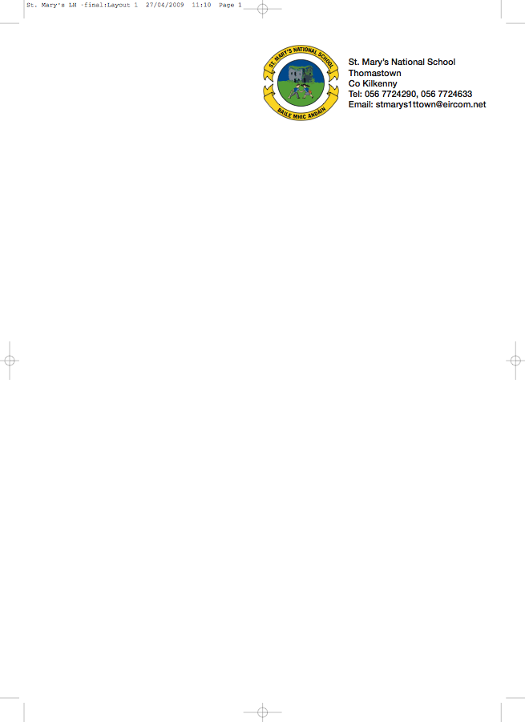

SECOND CLASS - BOOKLIST 2018/’19

Mr. Reade.

GAEILGE Céim ar Chéim Reader – “Chairde le Cheile” Leabhar 2
Céim ar Chéim Workbook Rang a Dó
(They come as a pack)

ENGLISH New Wave English in Practice – 2nd class (Prim-Ed)
New Wave Handwriting (2nd class) - Prim-Ed
Oxford Children’s Dictionary (Irish Edition CJ Fallon)

MATHS Busy At Maths 2 (CJ Fallon)
Mental Maths – 2nd class (Prim-Ed)
Table Toppers 2 (CJ Fallon)

COPIES 1 Homework Journal
6 x 88 page copies
1 Small Hardback Notebook
2 Plastic Pocket Folders to fit A4 paper (with front fastner)
1 Ruler
Pencils, red pen, crayons etc.
1 Large Hardback Notebook

To cover the cost of: Photocopying, Art & Craft, Pupil Insurance (24HR COVER).
Please put €40 in an envelope with the child’s name on it and give it to the teacher in September.

€15 is required for book rental to cover the cost of the new Literacy Programme, Spelling Book and other readers. Please put this amount in an envelope with your child’s name and give to the teacher in September.

No ‘wheelie’ bags. All school stationary available at Liam Reddy’s shop

School Uniform Details
The school uniform for Junior and Senior Infants is a track suit comprising a blue sweat shirt with school crest, navy pants and white polo shirt.

The school uniform for all other classes (1st to 6th class) is a grey shirt, grey trousers for boys and grey skirt or pinafore of appropriate length, for girls (trousers optional for girls), school tie (not elasticated type) and blue jumper with school crest.

On P. E. days and other designated days the pupils will wear a white polo shirt, plain navy track suit ends (not leggings) and a plain navy sweatshirt. During hot weather the children can wear Plain Navy Shorts (knee Length)

