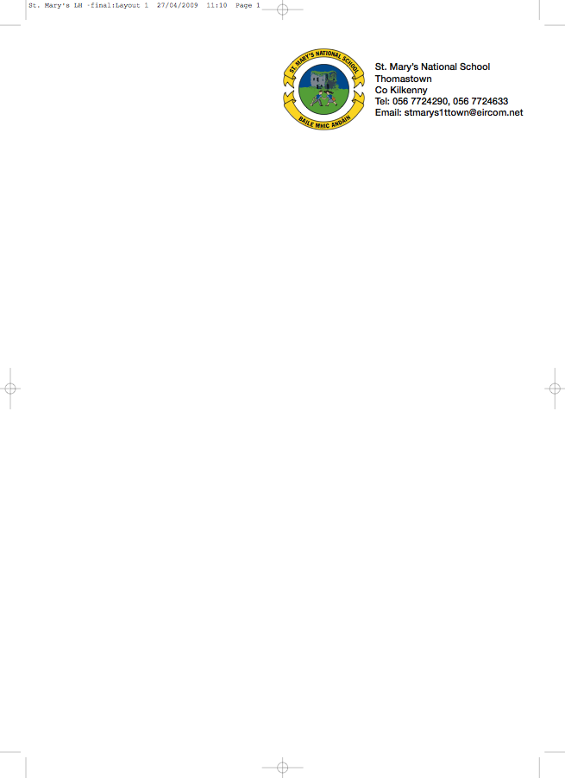

SECOND CLASS BOOKLIST 2017/’18
Mrs. Moore
ENGLISH New Wave English in practice (Prim-Ed Daily Workbook)
**Jolly Phonics 2 (Supplied in school)
Oxford Children’s Dictionary (Irish Edition)
Just Write 3a (Edco)
The Grumpy Teaspoon Core Reader Book 1
The Grumpy Teaspoon Activity Book
The Green Genie Combined Reading and Activity Book 2
Literacy Leap 2nd Class (Folens)

GAEILGE Céim ar Chéim Reader – “Chairde le Cheile” Leabhar 2
Céim ar Chéim Workbook Rang a Dó
(They come as a pack)

MATH Tables Book
Master Your Maths (Mental Maths) 2 (CJ Fallon)
Busy at Maths 2 (CJ Fallon) – Second Class

S.E.S.E. Window on the World Activity Book 2
MUSIC Recorder – available in school in September
COPIES/ 8 (88page) Writing Copies
SUPPLIES Homework Diary (C.J. Fallon)
Pencils, Rubber, Red Pen, Topper, Crayons
2 Plastic Pocket Folders to fit A4 paper (with front fastner)

- Please have covers and names on all books and copies
- Please put €40 into an envelope to cover the cost of photocopying art materials, pupil insurance (24hr cover) and ** Spelling Book. (The money is to be given to the teacher in September in an envelope with the child’s name on it).
- The English books (4) underlined above can be rented. If you wish to do so, please put €10 into a separate envelope and give it to the teacher in September.

.
No ‘wheelie’ bags.

All school stationary available at Liam Reddy’s shop

Please see overleaf for Uniform Details

