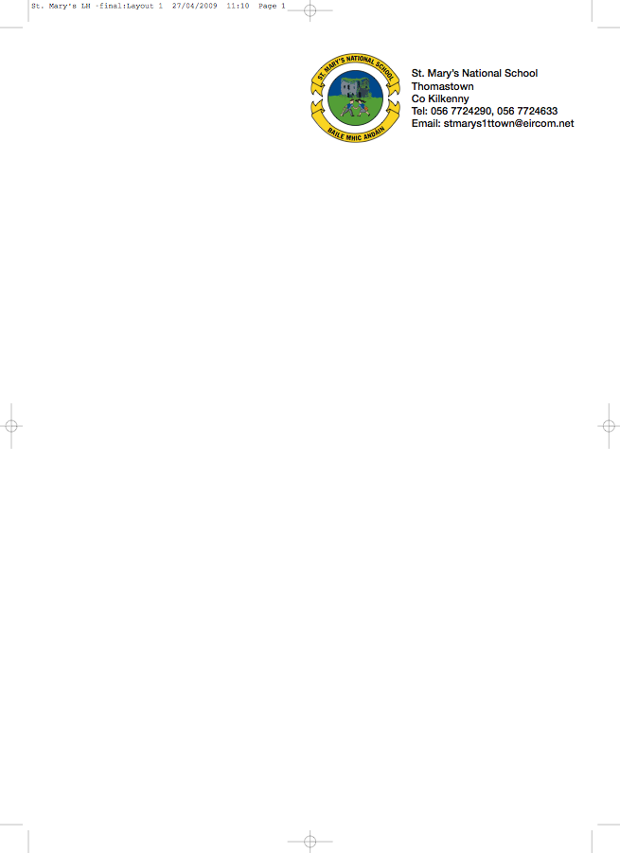

SECOND CLASS - BOOKLIST 2017/’18

Mr. Reade.

GAEILGE Abair Liom D (Folens)

ENGLISH The Grumpy Teaspoon – Core Reader Book 1 (Folens)
The Green Genie – Combined reading/Activity Book 2.(Folens)
The Grumpy Teaspoon – Activity Book (Folens)

New Wave English in Practice – 2nd class (Prim-Ed)
Just Write 3A (Edco)
Oxford Children’s Dictionary (Irish Edition CJ Fallon)

MATHS Busy At Maths 2 (CJ Fallon)
Mental Maths – 2nd class (Prim-Ed)
Time for Tables – (Edco)

MUSIC Music Made Easy Workbook 2nd Class

COPIES 1 Homework Journal
6 x 88 page copies
1 Small Hardback Notebook
2 Plastic Pocket Folders to fit A4 paper (with front fastner)
1 Ruler
Pencils, red pen, crayons etc.
1 Large Hardback Notebook

To cover the cost of: Photocopying, Art & Craft, Spelling Book, Pupil Insurance (24HR COVER).
Please put €40 in an envelope with the child’s name on it and give it to the teacher in September.

Literacy Lift Off - please put €15 in an envelope with your child’s name and give to the teacher in September.

The English books underlined above can be rented and if you wish to do so, please put €9 in a separate envelope and give it to the teacher in September.

No ‘wheelie’ bags.

All school stationary available at Liam Reddy’s shop

Please see overleaf for Uniform Details

