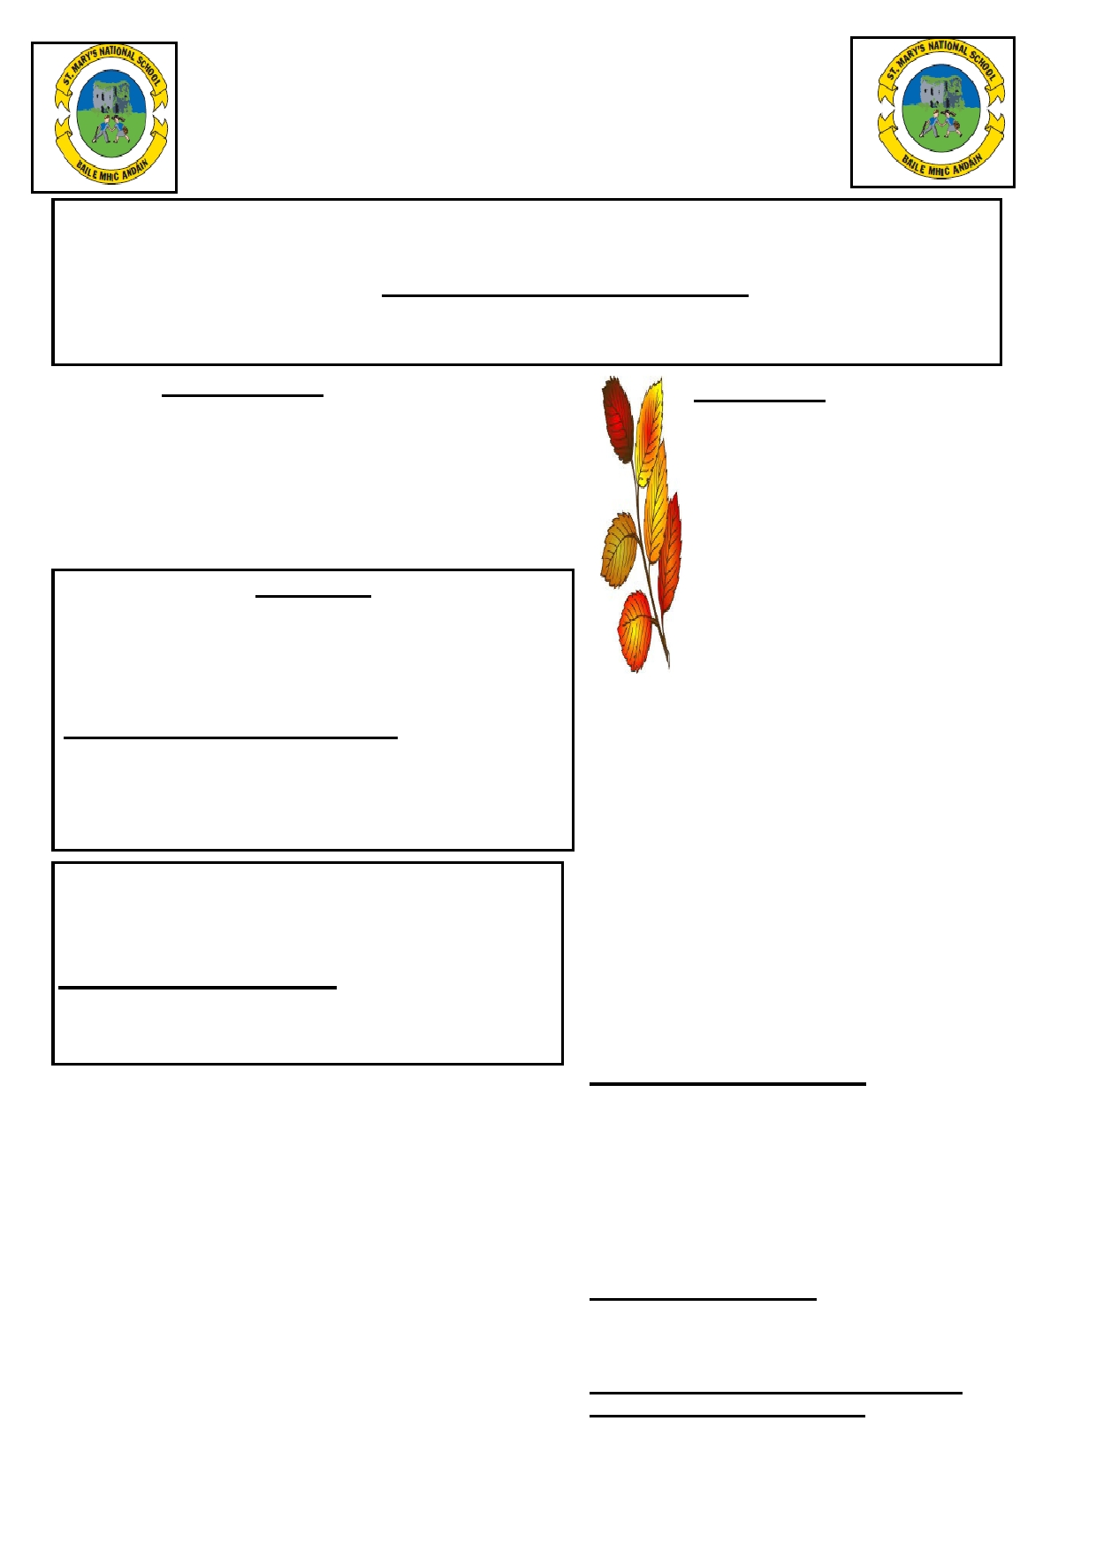
St. Mary's National School
NEWSLETTER
September 2015

Principal's welcome for the 2015-16 Year…All our pupils, especially the new pupils, are very wel-
come to our school. I hope they will have a very enjoyable time at St. Mary's. The beginning of the new school year Mass will take place on Tuesday, 22nd September at 11.30 am. All parents/guardians are welcome to attend - Some Junior classes will not attend.

Parents' Association
Election of class representatives for Junior
Infants.

RECYLE THOSE BATTERIES…….
Boxes are pro-

School Calendar:
Oct: School will close on Friday 23rd for the Halloween break.

Each class in the school is represented by a parent vided on each Nov: School will re-open on Mon.

on the Parents' Association. A letter will be sent
to the Junior Infant parents soon and this will start end of the corri-
2nd.
Dec: School will close on Tues. 22nd

the process of electing one parent from each of
the classes.

School Jackets
dor for used
batteries.
at 12.30pm for Christmas Holidays. Jan: School will re-open on wed. 6th Feb: School will be closed on Wed. 17th for Parent/Teacher meetings

School jackets are available from the school office. These Regatta jackets are school crested and of very good quality
costing €25. Please contact the school office to see samples. There are still some hurling helmets (small and large only) @
€35
Clearance of O'Neill Tracksuits….
There are five O'Neill tracksuits for sale clearing @ €20 each. Ages: 5/6 yrs , 7/8 yrs (this tracksuit is school crested), 9/10 yrs/ 10/11yrs and 13/14 yrs. These will be sold on a 'First Come First Serve' bases.

Application forms for the Rainbows Programme
are still available from the school office…. Please return the 'yellow' form which was included in the 'school rules' envelope.
Art/Craft & Photocopying - There are still
some outstanding amounts due on art/craft and photocopying. Payment would be much appreciated.

Well done to the past pupils of sixth class who raised €1,743 from the cake sale. they organised . A brilliant effort from all of them and thanks to all the parents for their support.

Credit Union - Saving in the school.
A staff member from the Credit Union attends the school every
Tuesday. Children from second class upwards will have the op-
School will close on Thurs 18th and
Fri 19th for Mid-Term break. School re-open Mon 22nd.

School Activities:
The boys' and girls' gaelic football school com- petitions have started.
Tag rugby will start during school time in Octo- ber for 7 weeks for 2nd - 6th class.
Dance Classes: Dance classes will be held for
the next three weeks for pupils in Second
class to sixth class. There is no charge for these classes as it is Board of Management funded.
Healthy Lunch Policy …
It is the policy of the school to encourage all children to
bring a healthy school lunch. Please see overleaf for healthy guidelines.

The Irish Blood Transfusion Service will attend the school on Thursday, 8th October.

New Database School System The school has a new database
system which will benefit the teachers and pupils.
If your contact details have changed since the
last school term, please inform the school
office as it is vital that all parents are

portunity to open a Credit Union account or make a lodgement to an contactable during school hours.

existing account. To open an account the child will need: a copy of
his/her birth certificate and note of P.P.S. no (which can be photo-
copied from the school files with parents permission). The aim is to
get children interested in saving, the minimum a child can lodge is €2.
Credit Union Art Competition…….
The Credit Union will hold an art competition in the school. All
details of the competition will be distributed to the teachers should they wish the class to part take.
Board of Management Note
School begins at 9.30am every morning and ends
at 3.10 pm every afternoon. The school will not be responsible for children outside school hours.
Parents are asked to have their children on
time for school every morning.
SCHOOL WEBSITE: WWW.STMARYSTTOWN.COM

