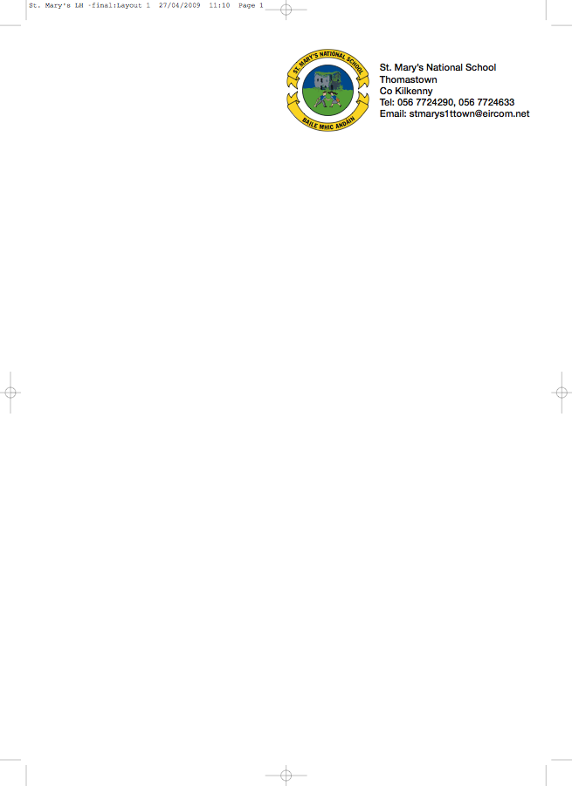

Senior Infants Booklist 2017/’18
Ms. Lanigan

GAEILGE Bua na Cainte B - (Edco)

ENGLISH
Reading Zone The Big Horse (Folens)

What a Mess! (Folens)

Stop That Dog (Folens)

The above 3 English Books are available secondhand from present Senior Infants

WORKBOOKS Activity Book for Readers 4 – 6 Selected Activities (Folens)

MATHS Cracking Maths – Senior Infants (Gill & MacMillan)

S.E.S.E. Windows on the World Activity Book B (Edco

A4 Envelope Folder

2 Topped Pencils

Rubber/Topper

Box of crayons/twistables (Not coluring pencils)

Please put the child’s name on outside cover of all books.

To cover the cost of: Photocopying, Copies, Plastic Folder, Jolly Phonics Workbook, Art & Personal Accident Insurance (24 hr cover) please put €35 in an envelope and give it to the teacher in September.

