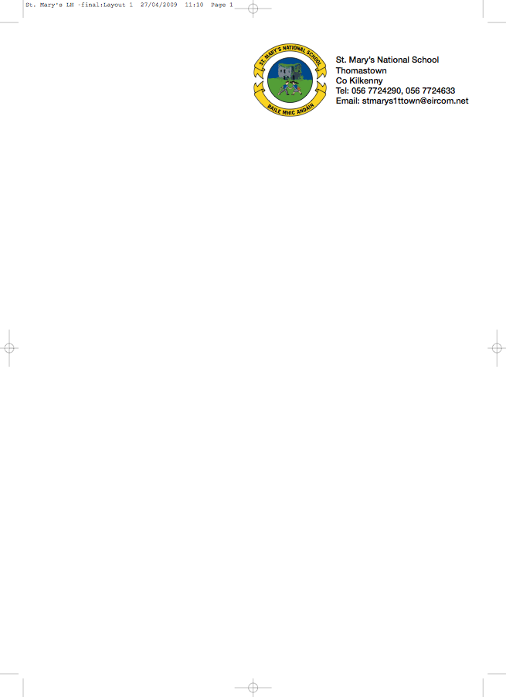

BOOKLIST 2017/’18

JUNIOR INFANTS 1 - Ms. Stapleton – Room1

GAEILGE Céim ar Chéim A – CJ Fallon

ENGLISH Reading Zone Pre-Reading Activity Book (Folens)
Just Write A1 Introduction to joined script and cursive writing (Edco)

MATHS Operation Maths Junior Infants (Edco)

To cover the cost of:

- COPIES/PENCILS/FOLDERS/CRAYONS. (These items will be purchased & distributed by the teacher).
- ART/CRAFT/PHOTOCOPY
- PERSONAL ACCIDENT INSURANCE (24 hour cover - includes activities outside school hours)

Please put €50 in an envelope with the child’s name marked clearly on the front.

Parents please
- Write your child’s name on all books/workbooks

- Have your child’s name on coats, jumpers, lunch boxes etc.

- Please put all books in a bag and give it to the teacher.

NOTE : School bags should be big enough to fit an A4 folder, lunch and a drink.

No ‘wheelie’ bags.

All school stationary available at Liam Reddy’s shop

