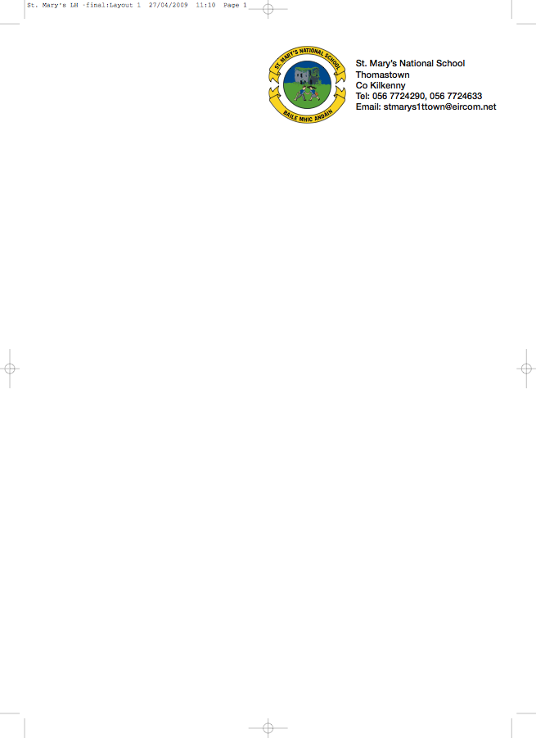

FIRST CLASS BOOKLIST 2017/’18

Ms. Power

ENGLISH A new Literacy programme has been introduced in 1st class. All reading books and workbooks for the programme MUST be rented.
Please put €15 in an envelope marked ‘Book Rental’ with your child’s name and return to the class teacher in September.

The following must be purchased:

SPELLING Jolly Phonics Grammar 1 Pupil Book

GAEILGE Bua na Cainte 1

MATHS Busy at Maths 1 (Fallons)
Time for Tables (Edco.)
Master Your Maths 1 (Fallons)

SESE Small World 1st Class (Fallons)

COPIES 1 Notebook (48 pages)
1 x 88page copy
2x 40page copy
1 Homework Diary (Fallons)
Box of Crayons/Colouring Pencils, Pencils
Rubber, Topper.

PLEASE HAVE COVERS AND NAMES ON ALL BOOKS & COPIES

- Please put €30 in a named envelope to cover the cost of photocopying, art materials, copies and pupil insurance (24hr cover) and give it to the teacher in September.

No Wheelie Bags

All school stationary available at Liam Reddy’s shop

Please see overleaf for Uniform Details

