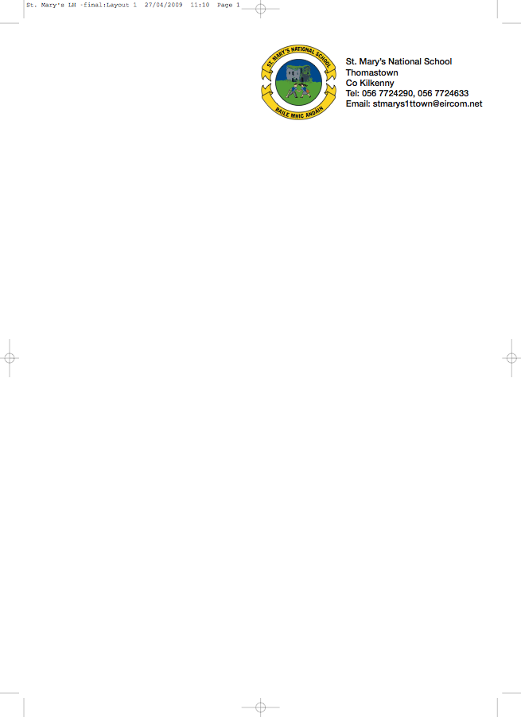

6th Class Booklist Mr.Delahunty
Irish: Sin é 6 edco
Fuaimeanna agus Focail 6 folens

English: Smart Ice Cream – Reading Zone fallons
English in Practice primed
Word Wizard 6th Class- Gill
Class Novels

Maths: Busy at Maths 6 cj fallon
Mental Maths 6th Class primed
Super Sleuth 6th Class Gill

SESE: Small World History
Unlocking Geography
Science Fusion 6 folens
English and Irish Dictionary
Copies:

3 X 120 page copies
4 X 120 page sum copies
3 x A5 Hardbacks
2 x A6 Hardbacks
4 x A4 Hardbacks
1 x Homework diary
1 x 30 page scrap book A3

Folder
80 Plastic Pockets
Maths set
U.S.B Key

Dear Parents/ Guardians,

The cost of all these books to buy is in excess of €200. The book rental scheme is € 80 and this includes everything on the list except English and Irish dictionaries. The children must bring these in along with their pencil cases. Everything else will be waiting for the children in the school in September. You do not need to go near a bookshop it will all be in the school in September ready for the new school year. To secure the books for next year I will be looking for the full amount before we finish on the 30th June. The usual €30 for art, craft and photocopying will be due in September.
Kind Regards,
Mr Delahunty

If you have any of these books at home the cost may be deducted from the total.

I _______________________ wish for my child ____________ to avail from the School book rental scheme.

