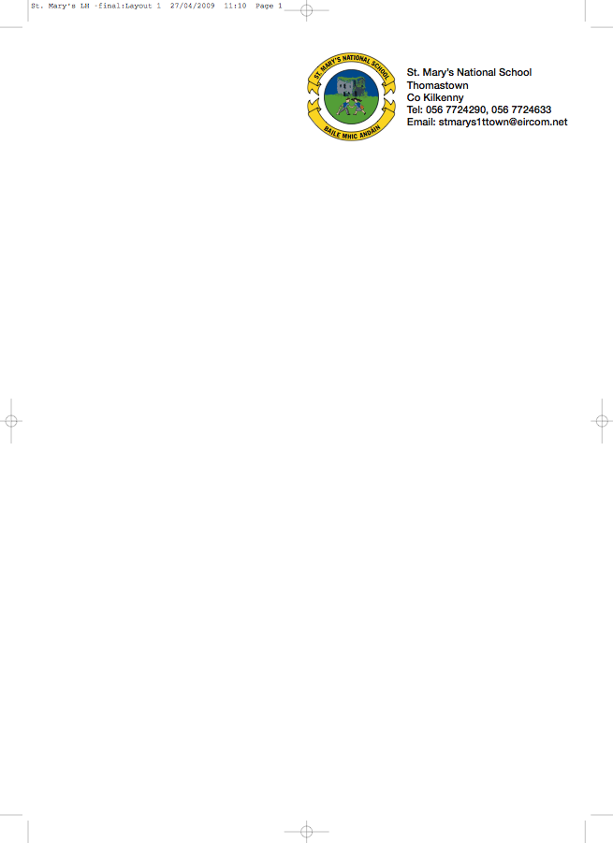

Fourth Class - BOOKLIST 2017/’18

Class Teacher: Ms. Hogan

GAEILGE Litrigh É Linn 4 (Edco)

ENGLISH Spellbound D (Folens)
English Dictionary
Just Write 4a (Edco)

MATHS New Wave Mental Maths 4th Class (Prim Ed) Tables champion 4 (Educate.ie)
Table Book

- 5 x 120 page copies 4 x 88 page copies 2 Squared Maths copies
(Please cover copies and write your name on the outside cover)
- Homework Diary
- 2 A4 Folders with Plastic Pockets
- 1 A4 Hardback Notebook
- 1 Scrapbook for projects
- Whiteboard Markers
- Pritt stick, scissors, colouring pencils, a red a blue pen and 2 pencils
Book Rental
Béal Beo 4
Grow in Love 4
Wordwise4
Word Wizard 4
Busy at Maths 4
Novels
History, Geography and Science
English Reader
Should you wish to avail of the book rental scheme, please put €30 in an envelope and give to me in September.
Please put €25 in a separate envelope for Art, craft, photocopying and pupil insurance (24 hr cover)

No Wheelie Bags
All school stationary available from Liam Reddy’s Shop

See overleaf for uniform details.

