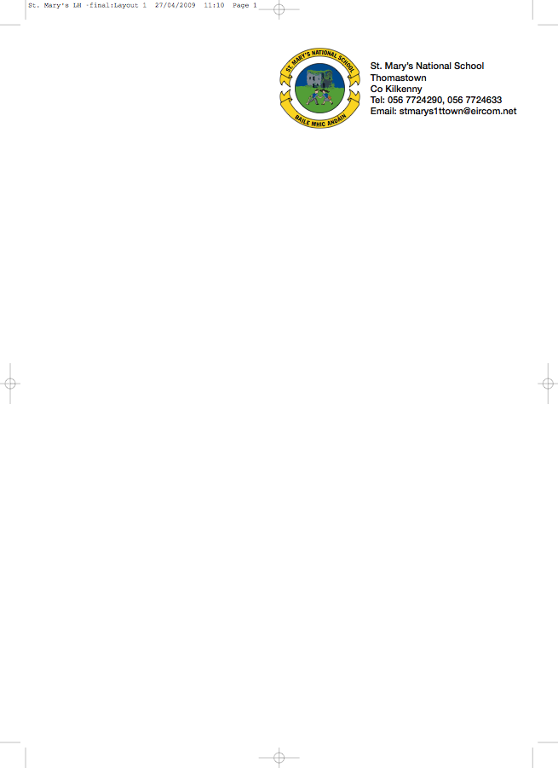

THIRD CLASS - BOOKLIST 2017/’18
Ms. Tyrrell.

GAEILGE Bun Go Barr 3 (Fallon) (€15 New / €5 to rent)
Ceartlitriú 3 (Fallon)

ENGLISH Reading Zone–The Talking Horse (€15 New / €5 to rent) Spell Well 3 (CJ Fallon)
Exercise your English 3 (EdCo) (€8.95 New / €3 to rent)
Oxford Children’s Dictionary
Just Write 4A (Edco)

MATHEMATICS Planet Maths 3 (Folens) (€15.25 New / €5 to rent)
Mental Maths 3 (Prim Ed)
Time for Tables (Ed Co)

MUSIC Recorder (Bought through the school)

COPIES 3 x 40 page copies
6 x 88 page copies
4 x 40 page Maths Copies or 2 x 88 page maths copies
Homework diary (Fallons)
2 x A4 Display Folder with Plastic Pockets used in 2nd class.
2 x HB pencils, 30cm ruler, red pen, rubber, topper, glue stick
colouring pencils or crayons.

RELIGION Grow in Love third class Primary 5

Please ensure all copies and books are labeled and covered.

- The books underlined above can be rented and if you wish to avail of the rental scheme please put €22 in an envelope with the child’s name on it and mark it ‘Book Rental’.

- To cover the cost of photocopying, History, Geography, Science, Music and Jolly Phonics worksheets (which will be organised through the school), please put €35 in an envelope with the child’s name on it and give to the teacher in September. This amount also covers art & craft & pupil insurance (24hr. cover) for the year and the purchase of 1 x Profile A4 Hardback Copy Book for SESE subjects. Many thanks.

No ‘Wheelie Bags’

All school stationary available from Liam Reddy’s shop

Please see overleaf for details of school uniform

