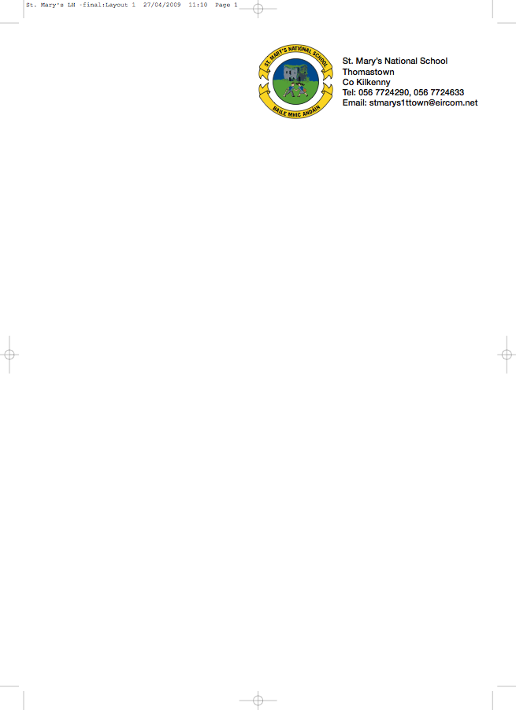

THIRD CLASS - BOOKLIST 2014/’15
Ms. Tyrrell.

GAEILGE Bun Go Barr 3 (Fallon) (€15 New / €5 to rent)
Ceartlitriú 3 (Fallon)

ENGLISH Bright Sparks (Available from Ms. Tyrrell in September for €1)
Spellbound Book C (Folens)
Exercise your English 3 (EdCo) (€8.95 New / €3 to rent)
Oxford Children’s Dictionary
Just Write 4A (Edco)

MATHEMATICS Planet Maths 3 (Folens) (€15.25 New / €5 to rent)
Mental Maths 3 (Prim Ed)
Time for Tables (Ed Co)

MUSIC Recorder (Bought through the school)

COPIES 4 x 40 page copies
2 x 80 page copies
1 x Profile A4 Hardback Copy – (approx. 160 pages)
4 x 40page Maths Copies
Homework diary (Fallons)
1 x A4 Folder
2 x red pens, pencils, ruler, rubber, topper, glue stick
colouring pencils or crayons.

Please put the child’s name on outside cover of all books and copies.

- The books underlined above can be rented and if you wish to avail of the rental scheme please
put €14 in an envelope with the child’s name on it and mark it ‘Book Rental’.

- To cover the cost of photocopying, History, Geography, Science, Grammar and Music (which will be organised through the school), please put €32 in an envelope with the child’s name on it and give to the teacher in September. This amount also covers art & craft & pupil insurance (24hr. cover) for the year.

