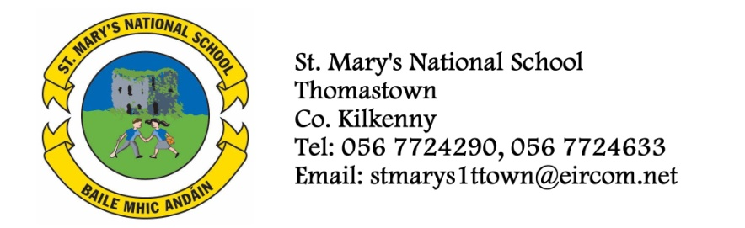

SECOND CLASS BOOKLIST 2014/’15
Mrs. Moore
ENGLISH Oxford Children’s Dictionary (Irish Edition)
Just Write 3a (Edco)
The Grumpy Teaspoon Core Reader Book 1
The Grumpy Teaspoon Activity Book
The Green Genie Combined Reading and Activity Book 2

GAEILGE Sin É 2 (Ed Co)

MATHS Mathemagic 2 (C.J.Fallon)
Tables Book

S.E.S.E. Window on the World Activity Book 2

MUSIC Recorder – available in school in September
COPIES/ 8 (88page) Writing Copies
SUPPLIES Homework Diary (C.J. Fallon)
Pencils, Rubber, Red Pen, Topper, Crayons
2 Plastic Pocket Folders to fit A4 paper (with front fastner)
- Please have covers and names on all books and copies
- Please put €35 into an envelope to cover the cost of photocopying art materials, pupil insurance (24hr cover) and Spelling Book. (To be given to the teacher in September in an envelope with the child’s name on it).
- The English books (3) underlined above can be rented. If you wish to do so, please put €9 into a separate envelope and give it to the teacher in September.

