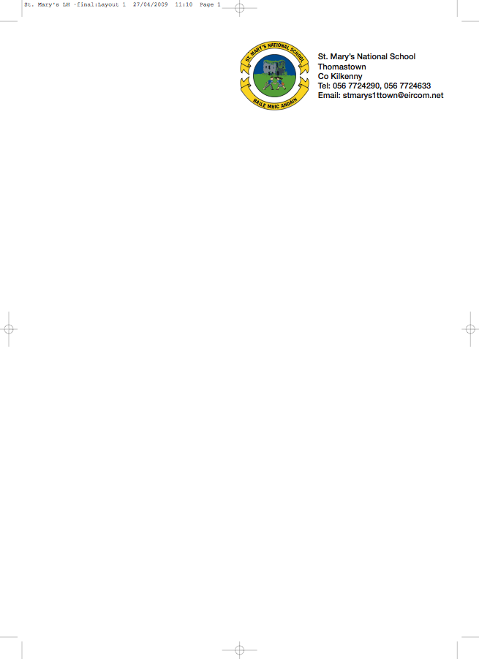

Senior Infants Booklist 2014/’15

Mrs. Lanigan

GAEILGE Treo Nua (Naíonáin Shinsearacha) (Folens)

ENGLISH
Reading Zone The Big Horse (Folens)

What a Mess! (Folens)

Stop That Dog (Folens)

The above 3 English Books are available secondhand from present Senior Infants

WORKBOOKS Activity Book for Readers 4 – 6 Selected Activities (Folens)

Ready to Write B1 (Edco)

MATHS Mathemagic Senior Infants Single Volume (CJ Fallon)

S.E.S.E. Windows on the World Activity Book B (Edco)

RELIGION Alive-O 2 Workbook

2 Topped Pencils

Rubber/Topper

Box of crayons/twistables

Please put the child’s name on outside cover of all books.

To cover the cost of: Photocopying, Copies, Plastic Folder, Jolly Phonics Workbook,
Art & Personal Accident Insurance (24 hr cover).

Please put €35 in an envelope and give it to the teacher in September.

