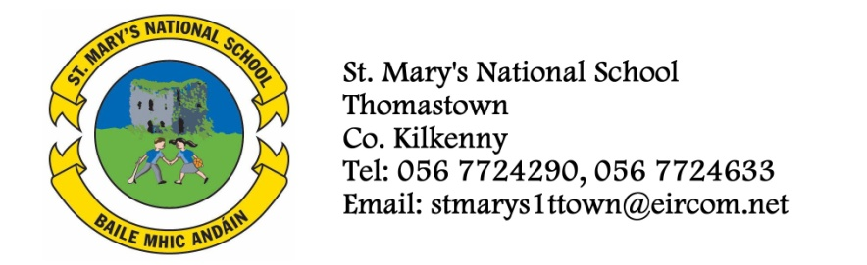

FIFTH CLASS - BOOKLIST 2014/’15

Ms. Hogan

GAEILGE Bun go Barr 5
Ceart Litriú 5 – CJ Fallon
Irish Dictionary
Beo le Ceo – (Maith Thú án Comhlacht Oideachais).

ENGLISH Reading Zone 5th Class – Call of the Sea
Exercise your English 5
Spellbound E (Folens)
Reasons to Write 5 (Edco)
English Dictionary
Novels, SRA, Nelson Reading Tree

MATHS Planet Maths 5th Class (Folens)
New Wave Mental Maths 5th Class (Prim Ed)

S.E.S.E. History, Geography and Science
Atlas

RELIGION Alive O 7 – Fifth Class Text Book

COPIES 8 x 120 pages copies
2 Squared Maths copies
Homework Diary
2 A4 Folders with Plastic Pockets (1 for recorder/1 for classroom use)
2xA4 Hardback Notebooks.
1 Scrapbook for projects.
Whiteboard Marker (Available in school 50c each)
Art, Craft, photocopying and pupil insurance (24 hr cover) – Please put €27 in an envelope and give to the teacher in September.

Book Rental (books underlined) - €30
Should you wish to avail of the book rental scheme, please put this amount in a separate envelope and give to the teacher in September.

