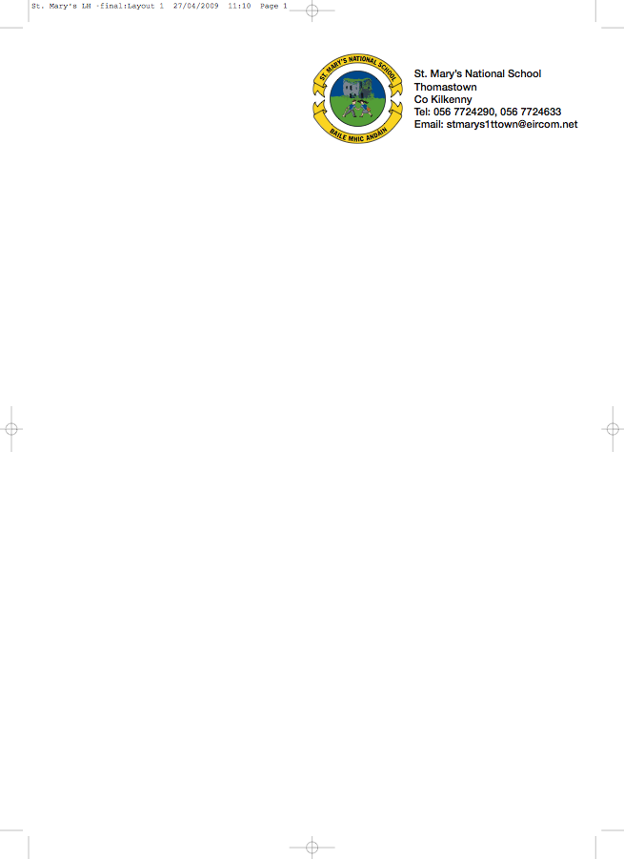

FIRST CLASS BOOKLIST 2014/’15

Ms. Doyle

GAEILGE Sin É 1 (Edco)

ENGLISH Finn’s Dream (Folens)
Finn’s Dream Activity Book 1 (Folens)
The Four Friends ( Folens)
The Four Friends Activity Books 2 (Folens)
Two Little Frogs combined reading and activity book

MATHS Planet Maths 1st Class (Folens)
Time for Tables (Edco.)
New Wave Mental Maths (1st Class) – (PrimEd)

COPIES 1 Notebook
2 x 88page copy
1x 40page copy
1 Homework Diary (Fallons)

Display Folder with 40 plastic pocket

Box of Crayons/Colouring Pencils, Pencils
Rubber, Topper.

PLEASE HAVE COVERS AND NAMES ON ALL BOOKS & COPIES

- Please put €30 in a named envelope to cover the cost of photocopying, art materials, copies, a spelling book and pupil insurance (24hr cover) and give it to the teacher in September.

- The books highlighted and underlined above can be rented. If you wish to avail of the book rental scheme please put €12 in a separate envelope for book rental.

