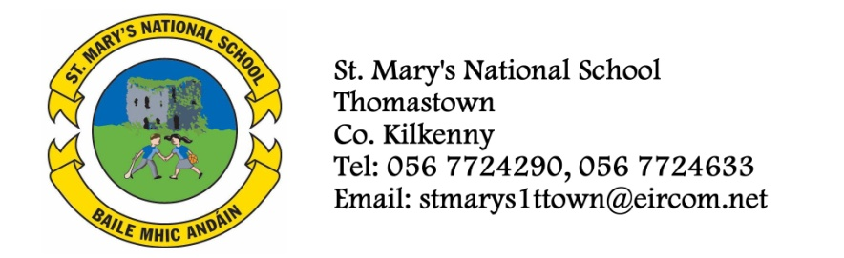

BOOKLIST FOR 4th CLASS - 2013/’14

Class Teacher - Ms. O’Connor

Subject Name
IRISH: Sin É! 4

ENGLISH: It’s Not Fair and Other Stories-Revised Ed (available to rent)
Flying Free and Other Stories-Revised Ed (available to rent)
A-Z of Finding Out (available to rent)
Novel (available to rent only)
Reasons to Write 4
Spellbound (Folens) Book D

MATHS: Planet Maths 4 (available to rent)

School Insurance, Photocopying, Art - €37 (Please put this amount in an envelope with the child’s name on it and give it to the teacher in September)
Included in the €35 charge is €7 for insurance, €5 for the cost of photocopying for SESE (no books are required to be purchased) and €4 for the rent of an English novel. Parents are required to return the English novel rented in a condition suitable for reuse by children in future years.
Homework Journal - Fallons
3x88 page Maths copies
3x88page (A11) writing copies
3x40page (A12) writing copies
1 Learn to Write B2 copy
2 notebooks

All children must have:
- Atlas
- Table Book
- English Dictionary (Oxford New Children’s Dictionary, Irish Edition, recommended)
- Recorder (available through the school)
- Folder with plastic pockets
- 2 HB pencils, blue Bic pen, red Bic pen, rubber, ruler, pencil sharpener
- Small box of colouring pencils
- Pritt Stick
Please ensure all copies and notebooks are covered.

