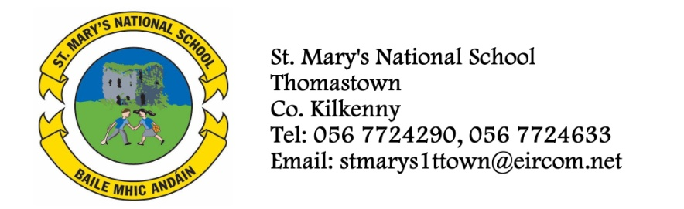

Book Rental
To reduce the cost of books to parents, the school is continuing with the book rental scheme.
Savings can be made by availing of this scheme. The 4 books listed below are available for rent.
The cost of these books new and rented is as follows:

Book Cost To Buy Rental Cost

- It’s Not Fair and Other Stories (Revised Ed) €7.60 €2.60
- Flying Free and Other Stories (Revised Ed) €7.60 €2.60
- A-Z of Find Out €7.20 €2.50
- Planet Maths 4 €15.75 €5.30
€38.15 €13.00

Parents can choose one of the following Options:
Option A - Purchase books 1 to 4 above themselves.

Option B - Rent books 1 to 4 from the school. At the end of the academic year, parents are required to return the books to the school. The books must be returned in a condition suitable for reuse by pupils in future years. If a parent wishes to avail of this option, parents must include the €13 in the envelope with the €37 in September.

Option C – Rent some books and buy some books. If a parent wishes to avail of this option, please list the books below which will be rented and include the exact rental cost in the envelope with the €37 in September.

Please fill in and return the details below so that we know how many books to order. The books will be given to the children in September. (Select one option only)
……………………………………………………………………………………………………………………………..

Option A – I will purchase the books listed at 1 to 4 above.

Option B – I will rent the books listed at 1 to 4 above.

Option C – I will rent the following book: Please tick

- It’s Not Fair and Other Stories €2.60 _______

- Flying Free and Other Stories €2.60 _______

- A-Z of Finding Out €2.50 _______

- Planet Maths 4 €5.30 _______

Signed: _______________________________ Pupil Name:____________________________
Parent/Guardian

Teacher (4th Class) ______________________________

