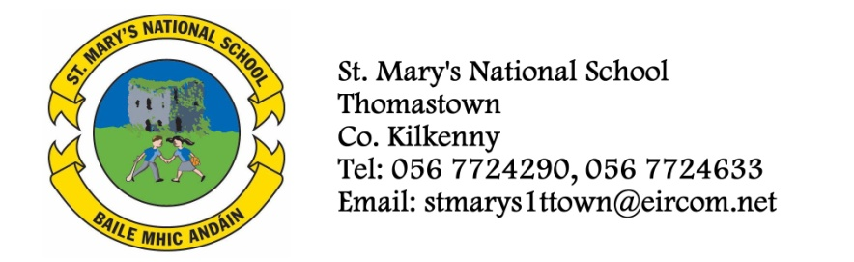

Fifth Class Booklist 2013/’14

Ms. Hogan

GAEILGE Bun go Barr 5 - CJ Fallon
Litrigh é Linn 5 – Edco
Irish Dictionary

Beo le Ceo – (Maith Thú án Comhlacht Oideachais).
ENGLISH Reading Zone 5th Class – Call of the sea
Exercise your English 5
Spellbound E (Folens)
English Dictionary
Novel (to be decided)
MATHEMATICS Planet Maths 5th class (Folens)
New Wave mental maths 5th class (Prim-Ed)
S.E.S.E. History, Geography and Science
Atlas
RELIGION Alive O 7 – Fifth Class Text Book

COPIES 8X120 page
Homework Diary
2 A4 Folders with plastic pockets (1 for recorder/1 for classroom use)
2xA4 Hardback Notebooks

Art, Craft, photocopying and pupil insurance (24 hr Cover) – Please put €27 in an envelope and give to the teacher in September.

Book Rental (books underlined) - €28
Should you wish to avail of the book rental scheme, please put this amount in a separate envelope and give to the teacher in September.

