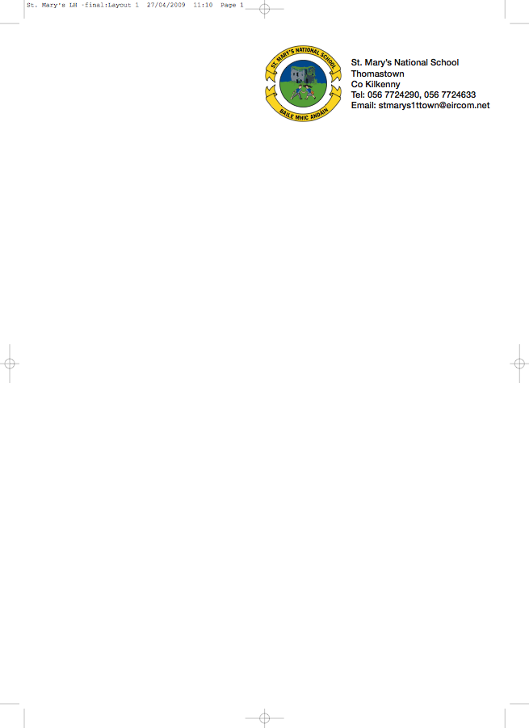

BOOKLIST 2013/’14

JUNIOR INFANTS 3 - Ms. A. Stapleton – Room 3

GAEILGE Treo Nua – Junior Infants (Folens)

ENGLISH Reading Zone Pre-Reading Activity Book (Folens)
Just Write A1 Introduction to joined script and cursive writing (Edco)

MATHS Mathemagic – Junior Infants Single Volume (CJ Fallon)

ENVIRONMENTAL STUDIES: Windows on the World Activity Book A - Edco

To cover the cost of:

- COPIES/PENCILS/FOLDERS
- CRAYONS & JOLLY PHONICS TEXT BOOK (These items will be purchased and distributed by the teacher)
- ART/CRAFT/PHOTOCOPY
- PERSONAL ACCIDENT INSURANCE (24 hour cover - includes activities outside school hours)

Please put €45 in an envelope with the child’s name marked clearly on the front.

Parents please
- write your child’s name on all books/workbooks

- Have your child’s name on coats, jumpers, lunch boxes etc.

- Please put all books in a bag and give it to the teacher.

