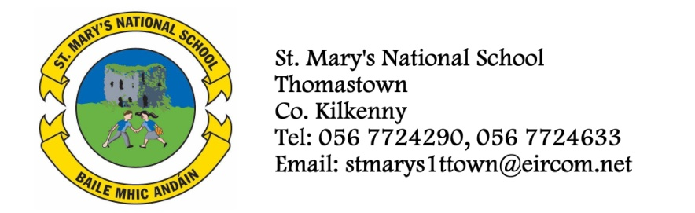

SECOND CLASS - BOOKLIST 2013/’14
Mrs. Troy.
GAEILGE Bun go Barr 2

ENGLISH The Grumpy Teaspoon – Core Reader Book 1 (Folens)
The Grumpy Teaspoon – Activity Book (Folens)
The Green Genie – Combined reading/activity Book 2.(Folens)
Just Write 3A (Edco)
Oxford Children’s Dictionary (Irish Edition)

MATHS Mathemagic 2 (CJ Fallon)
Time for Tables (Edco)

S.E.S.E. Earthlink 3 Activity Book (Only)

MUSIC Recorder (Bought through the school in September)

COPIES 1 Homework Journal
4 x 88 page copies
1 Notebook
2 Plastic Pocket Folders to fit A4 paper (with front fastner)
1 Ruler
Pencils, red pen, crayons etc.
To cover the cost of: Photocopying, Art & Craft, Spelling Book, Pupil Insurance (24HR COVER).
Please put €35 in an envelope with the child’s name on it and give it to the teacher in September.

The English books underlined above can be rented and if you wish to do so, please put €9 in a separate envelope and give it to the teacher in September.

