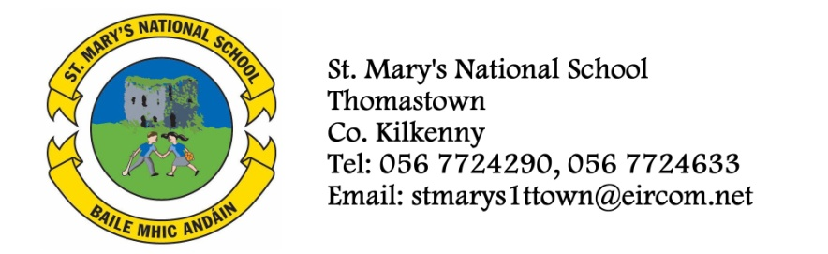
THIRD CLASS 1. - BOOKLIST 2013/2014
Mrs. Troy
GAEILGE Bun Go Barr 3 (Fallon) (€5 to rent)

ENGLISH Get Set (Fallons) (€5.50 to rent)
Exercise your English 3 (EdCo)(€3 to rent)
Oxford Children’s Dictionary (Irish Edition)
Spellbound 3 (Fallons)
Just Write 4A (Edco)

MATHEMATICS Mathemagic 3 (€2 to rent)
Time for Tables (Edco)

S.E.S.E. Earthlink 3 Textbook (€2 to rent)
Earthlink 3 – Activity Book

MUSIC Recorder (Bought through the school)
COPIES 6 x 88page copies
Homework Diary
1 x A4 display book (60 pocket)
Blue pen, red pens, pencils, ruler, rubber, topper, glue stick
colouring pencils or crayons.
- Please ensure that your child’s name is labelled clearly on the outside cover of all books and copies.
- The books highlighted and underlined are available to rent, if you wish to do so please put €17.50 in a separate envelope and give to the teacher in September.
- To cover the cost of art/craft, photocopying and pupil insurance (24hr cover), please put €30 in an envelope with the child’s name on it and give to the teacher in September.

