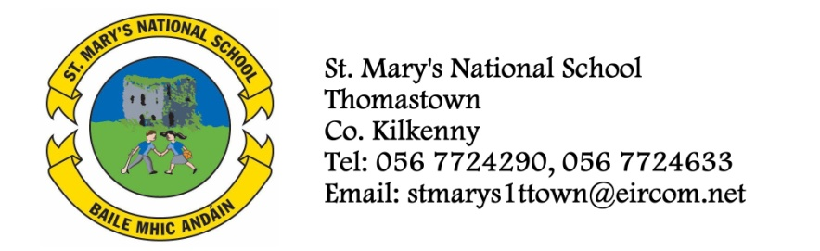

Sixth Class – Booklist 2013/2014
Mr. Delahunty
Gaeilge Sin é 6
Litrigh é Linn 6*
Graimeír le Chéile 6*

English Smart Ice Cream – Reading Zone
Exercise your English 6
My Spelling Workbook*

Maths Mathemagic 6*
Mental Maths 6th Class

Geography Geography Quest 6

History History Quest 6

Science Science Quest 6
English and Irish Dictionary
Mathematical set
Copies: 8 x 120 page copies
3x 120 page sum copies
3 x A5 Hardbacks
1 x A6 Hardback
1x A4 Hardback
Colours, pens and pencils.
School Rental Scheme: The books marked with an asterix are workbooks that your child will write in and thus can’t be rented. The cost of all these books to buy is over €150. With the school book rental scheme the cost will be €70 and your child will have all the books in the school ready to go in September, including copies. All they need is their pencil cases and dictionaries from this year. You won’t have to go near a bookshop. If you have any of these books at home the cost may be deducted from the total.
To cover the cost of Art/Craft, Photocopying and Pupil Insurance (24hr cover), please put €30 in an envelope and give it to the teacher in September.
(Parents, please ensure that you have signed the Rental Agreement Form)
I ___________________________ wish for my child to avail from the School Book Rental Scheme.

