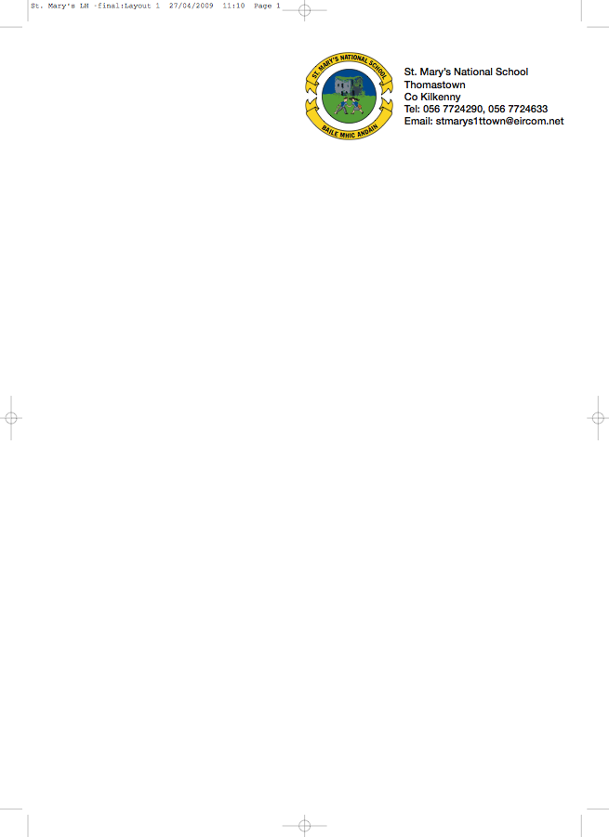

THIRD CLASS 1. - BOOKLIST 2012/2013

Ms. O’Shea

GAEILGE Bun Go Barr 3 (Fallon) (€5 to rent)

ENGLISH Get Set (Fallons) (€5.50 to rent)
Exercise your English 3 (EdCo)(€3 to rent)
Oxford Children’s Dictionary (€3.50 to rent
Spellbound 3 (Fallons)

MATHEMATICS Planet Maths 3 (Folens) (€5 to rent)
Mental Maths 3 (Prim Ed)
Time for Tables (Ed Co)

RELIGION Alive-O Workbook 5

MUSIC Recorder (Bought through the school)

COPIES 6 x 88page copies
1xProfile A4 Hardback Copy
Homework Diary
1 x A4 display book (60 pocket)
Blue pen, red pens, pencils, ruler, rubber, topper, glue stick
colouring pencils or crayons.

Please ensure that your child’s name is labelled clearly on the outside cover of all books and copies.

The books highlighted and underlined are available to rent, if you wish to do so please put €22 in a separate envelope and give to the teacher in September.

To cover the cost of art/craft, photocopying and pupil insurance (24hr cover), please put €30 in an envelope with the child’s name on it and give to the teacher in September.

School supplies are available from Thomastown Office Supplies, Marshes St. Thomastown.

