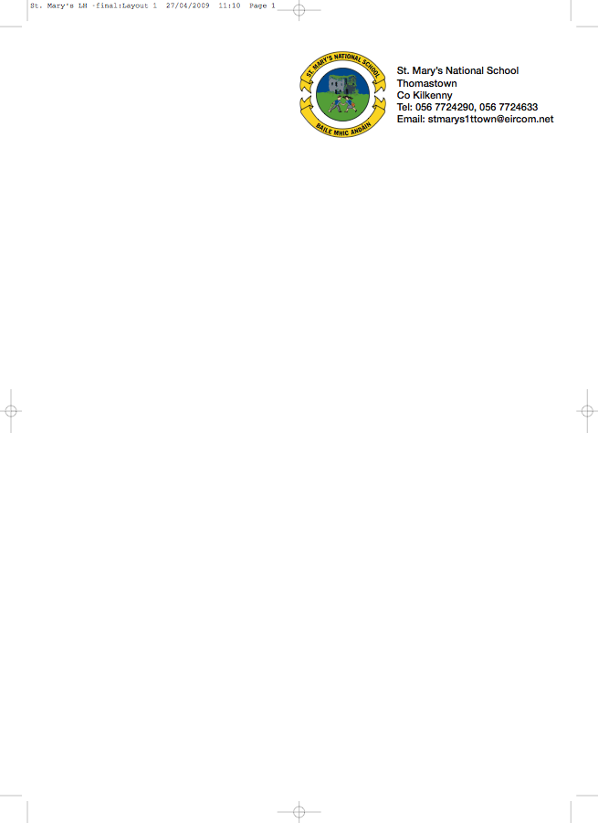

THIRD CLASS - BOOKLIST 2012/’13

Ms. Tyrrell.

GAEILGE Bun Go Barr 3 (Fallon) **** (€15 New / €5 to rent)
Ceartlitriú 3 (Fallon)

ENGLISH Bright Sparks (Fallon)*
Spellbound Book C (Folens)
Exercise your English 3 (EdCo) **** (€8.95 New / €3 to rent)
Oxford Children’s Dictionary **** (€12.45 New/ €3.50 to rent)

MATHEMATICS Planet Maths 3 (Folens) **** (€15.25 New / €5 to rent)
Mental Maths 3 (Prim Ed)
Time for Tables (Ed Co)

MUSIC Recorder (Bought through the school)

COPIES 5 x 40 page copies
2 x 80 page copies
1 x Profile A4 Hardback Copy
4 x 40page Maths Copies
Homework diary (Fallons)
1 x A4 display book
2 x red pens, pencils, ruler, rubber, topper, glue stick
colouring pencils or crayons.

* Can be bought second hand from present 3rd class.
**** Available from book rental scheme for approximately 1/3 of the price of the new book.

If you avail of all the books from the book rental scheme you can save €35.15

Please ensure all copies and books are covered and that your child’s name is labelled clearly on the outside cover.

To cover the cost of purchasing workbooks for History, Geography, Science and Music (which will be organised through the school), please put €35 in an envelope with the child’s name on it and give to the teacher in September. This amount also covers photocopying, art & craft & pupil insurance (24hr. cover) for the year.

