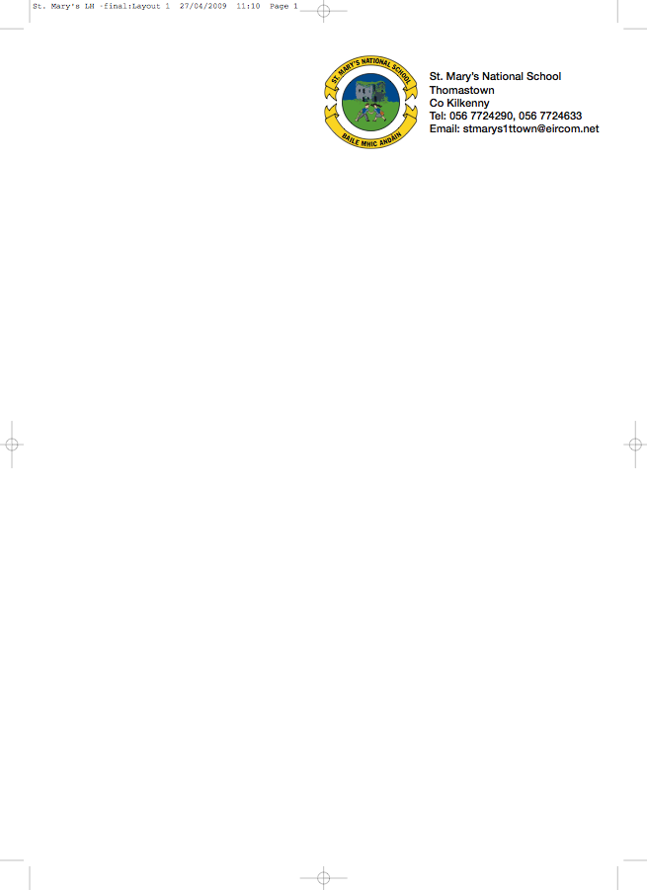

Sixth Class – Booklist 2012/2013
` Mr. Delahunty

Gaeilge Sin é 6*
Litrigh é Linn 6*
Graimeír le Chéile 6*

English Smart Ice Cream – Reading Zone
Exercise your English 6
My Spelling Workbook*

Maths Mathemagic 6
Mental Maths 6th Class

Geography Geography Quest 6

History History Quest 6

Science Science Quest 6

English and Irish Dictionary

Mathematical set

Copies: 8 x 120 page copies
3x 120 page sum copies

2 x A5 Hardbacks
2 x A6 Hardback
1x A4 Hardback

Colours, pens and pencils.

As you may have heard the school is in the process of establishing a school book rental scheme. The books marked with an asterix are workbooks that your child will write in and thus can’t be rented. The cost of all these books to buy is over €150. With the school book rental scheme the cost will be €75 and your child will have all the books in the school ready to go in September, including copies. All they need is their pencil cases and dictionaries from this year. You won’t have to go near a bookshop. If you have any of these books at home the cost may be deducted from the total. I will be collecting a deposit of €40 before the 28th June.

I ___________________________ wish for my child to avail from the School Book Rental Scheme.

