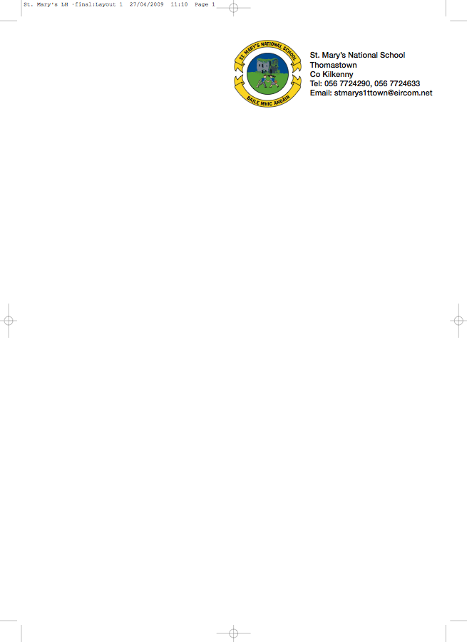

SECOND CLASS - BOOKLIST 2012/’13

Mrs. Troy.

GAEILGE Bun go Barr 2

ENGLISH The Grumpy Teaspoon – Core Reader Book 1 (Folens)
The Grumpy Teaspoon – Activity Book (Folens)
The Green Genie – Combined reading/activity Book 2.(Folens)
Look, Listen and Learn Phonics Activity Book (CJ Fallon)
My Spelling Workbook C (Prim Ed)
Just Write 3A (Edco)

MATHS Mathemagic 2 (CJ Fallon)

S.E.S.E. Window on the World Activity Book 2

MUSIC Recorder (Bought through the school in September)

COPIES 1 Homework Journal
4 x 88 page copies
1 Notebook
2 Plastic Pocket Folders to fit A4 paper (with front fastner)
1 Ruler
Pencils, red pen, crayons etc.

PHOTOCOPYING/ART & CRAFT & PUPIL INSURANCE (24HR COVER)
Please put €27 in an envelope with the child’s name on it and give it to the teacher in September.

The English books underlined above can be rented and if you wish to do so, please put €9 in a separate envelope and give it to the teacher in September.

All school Books and School Supplies are available from Thomastown Office Supplies, Marshes St.

