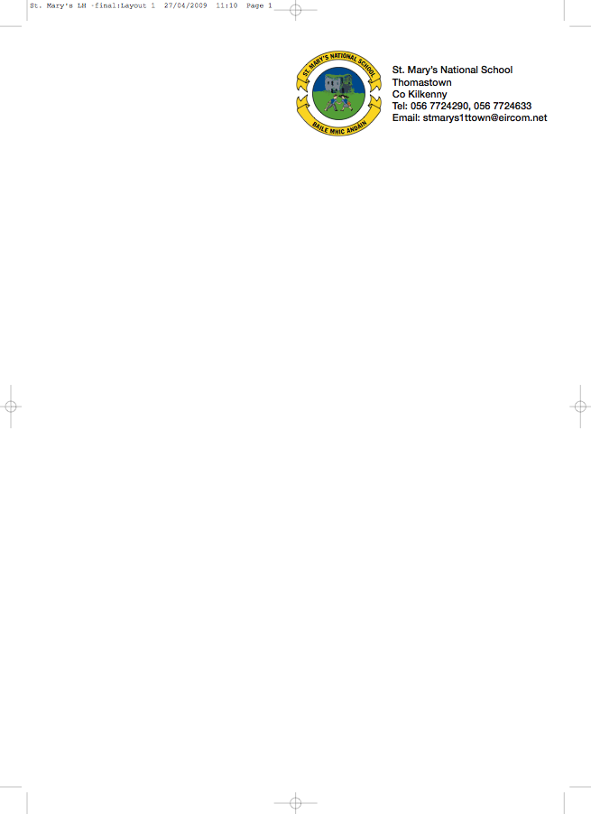

SECOND CLASS BOOKLIST 2012/’13
Mrs. Moore

ENGLISH My Spelling Workbook C (Prim Ed)
Look Listen and Learn! Phonics Activity Book - second class - C.J. Fallon
Just Write 3a (Edco)
The Grumpy Teaspoon Core Reader Book 1
The Grumpy Teaspoon Activity Book
The Green Genie Combined Reading and Activity Book 2

GAEILGE Sin É 2 (Ed Co)

MATHS Mathemagic 2 (C.J.Fallon)
Tables Book

S.E.S.E. Window on the World Activity Book 2

MUSIC Recorder – available in school in September

COPIES/ 8 (88page) Writing Copies
SUPPLIES Homework Diary (C.J. Fallon)
40 Pages A4 Display Book
Pencils, Rubber, Red Pen, Topper, Crayons

- Please have covers and names on all books and copies

- Please put €27 into an envelope to cover the cost of photocopying, art materials and pupil insurance (24hr cover) and give it to the teacher in September.

- The English books (3) underlined above can be rented. If you wish to do so, please put €9 into a separate envelope and give it to the teacher in September.

School Books & School Supplies are available at Thomastown Office Supplies, Marshes St.

