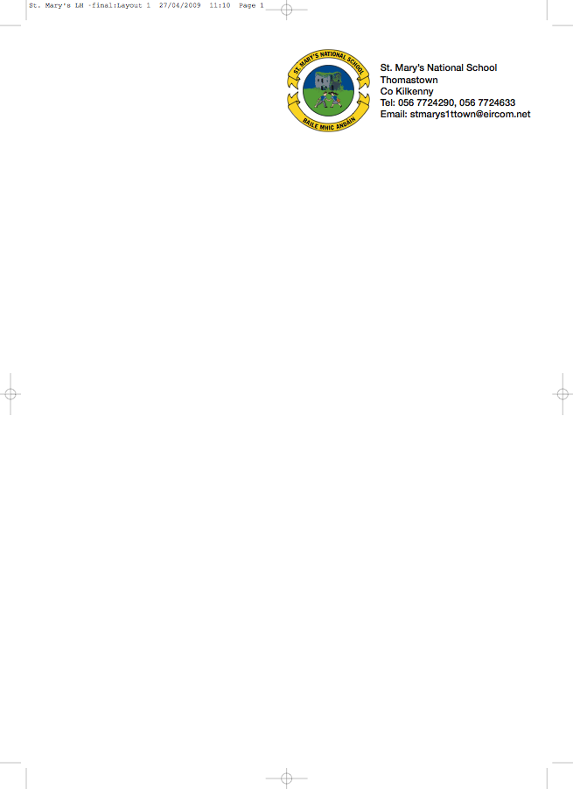

BOOKLIST 2012/’13

JUNIOR INFANTS 3 - Ms. A. Stapleton - Room 3

GAEILGE Treo Nua – Junior Infants (Folens)

ENGLISH Reading Zone Pre-Reading Activity Book (Folens)
Just Write A1 Introduction to joined script and cursive writing (Edco)

MATHS Mathemagic – Junior Infants Single Volume (CJ Fallon)

ENVIROMENTAL STUDIES Windows on the World Activity Book A – Edco

COPIES/PENCILS/FOLDERS
CRAYONS & JOLLY PHONICS TEXT BOOK - These items will be purchased and distributed by the teacher. Please put €10 in an envelope with your child’s name on it and give it to the teacher.

ART/CRAFT/PHOTOCOPY €20.00 Please put exact amount in an envelope with your Child’s name on it and give it to the teacher.

PERSONAL ACCIDENT INSURANCE €7.00 for 24 hour cover (please put in a separate envelope)

Parents please
- write your child’s name on all books/workbooks

- Have your child’s name on coats, jumpers, lunch boxes etc.

- Please put all books in a bag and give it to the teacher.

Please note all books and educational supplies are available from Thomastown Office Supplies, Marshes St. Thomastown

