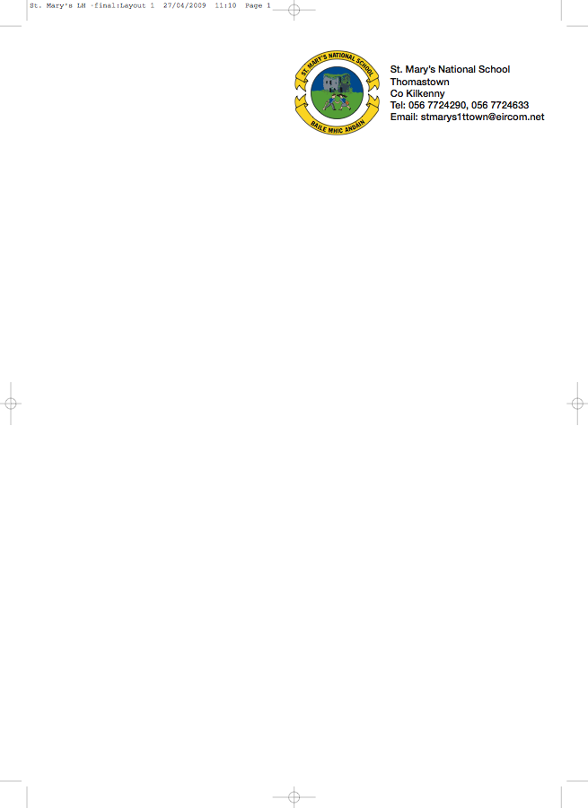

FOURTH CLASS - BOOKLIST 2012/’13

Mrs. Murphy.

GAEILGE Inis Dom 4.

ENGLISH English Dictionary

MATHS Brain Teasers 4 (Fallons)
Table Book

S.E.SE./S.P.H.E. Earthlink 4th Class Workbook only

MUSIC Recorder (Bought through the school)

COPIES 10 x 120 page copies
Fallons Homework Journal
2 x A 4 Display Book (1 x 60 pocket & 1x 40 pocket)

To cover (1) Book Rental (2)Photocopying (3) pupil insurance (24hr cover) (4) Art & Craft please put €50 in an envelope with the child’s name on it and give it to the teacher.

The children will have the use of the following books:

- Blue Skies Stories & Poetry
- Fallons Spelling Book
- Mathemagic 4
- Earthlink 4th class book
- Alive O 6 book
- A Way With Words 4
(If the above books are bought new the cost will be €67)

All school books and school supplies are available from Thomastown Office Supplies, Marshes St.

