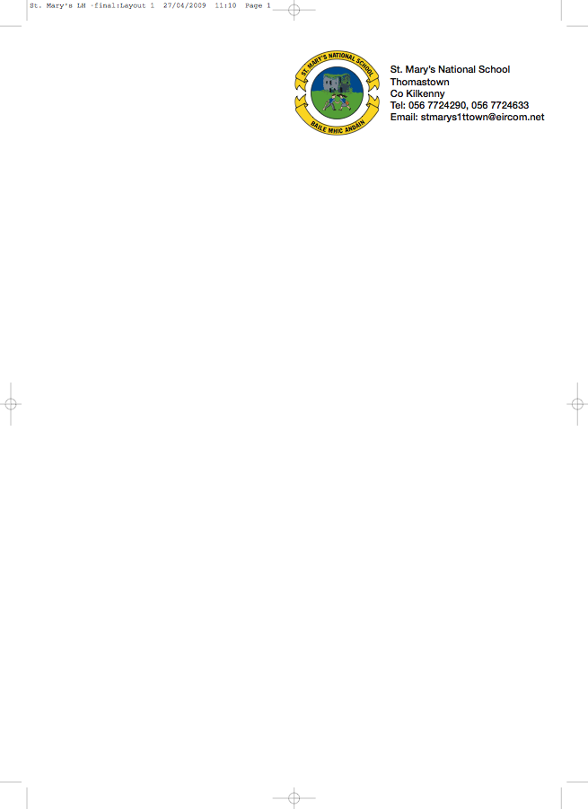

Fifth Class 2012-13

Mrs Dowling

Gaeilge Bun go Barr 5 (available to rent)
Litrigh É Linn 5 (Edco) Work book must be bought new

English Reading Zone: Call of the Sea (available to rent)
Exercise Your English 5 (available to rent)
Spellbound E (Folens) workbook
Novel (available to rent)
English Dictionary: Oxford Children's Dictionary Irish Edition Recommended

Maths Mathemagic 5 (available to buy 2nd hand (not included in book rental)
New Wave Mental Maths 5th Class (prim-ed) Workbook
Table book

S.E.S.E History, Geography & Science (Available to rent)
Please do not purchase books new as we use different books throughout the year

Religion Alive O 7 Pupils Text Book (available to rent)
Alive O 7 Workbook (not the Confirmation edition)

Copies 4x120 page
5x 88page
2 Maths Copies
Homework Diary
2 Notebooks
1xA4 Hardback
Folder with Plastic Pocket

Art & Craft, photocopying and pupil Insurance (24hr cover - cost €7). Please put a total of €27 in an envelope and give to the teacher in September.

If you wish to avail of Book Rental (all underlined books), please put €24 in a separate envelope with child's name and give to the teacher in September.

School Supplies are available from Thomastown Office Supplies, Marshes St., Thomastown.

